**Part 1: Screenshots that summarize** [**the book**](https://matrixtrainings.files.wordpress.com/2015/06/mebane_t-_faber_eric_w-_richardson_the_ivy_portbookzz-org.pdf)

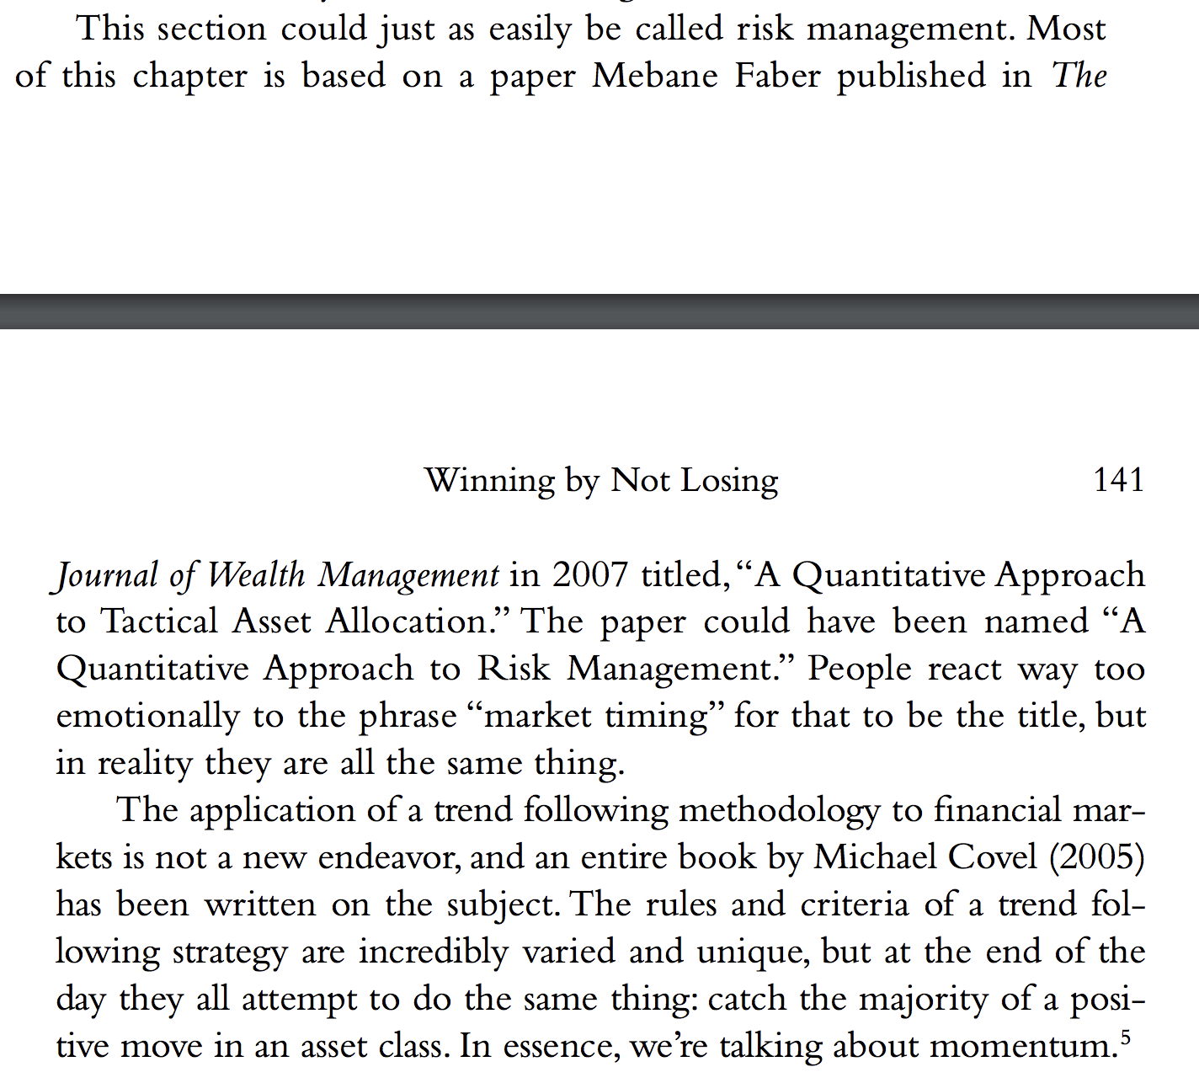

[Here is the paper its based on](https://www.trendfollowing.com/whitepaper/CMT-Simple.pdf)

[Here is an update to the paper](https://www.nicklumpp.com/wp-content/uploads/2016/12/Tactical-Asset-Allocation_10-month-SMA.pdf)

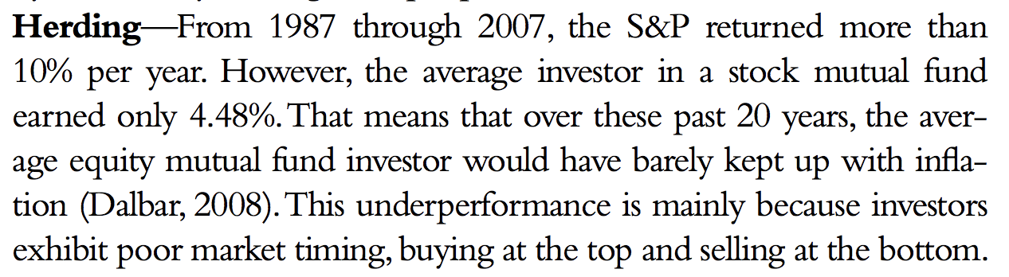­­­

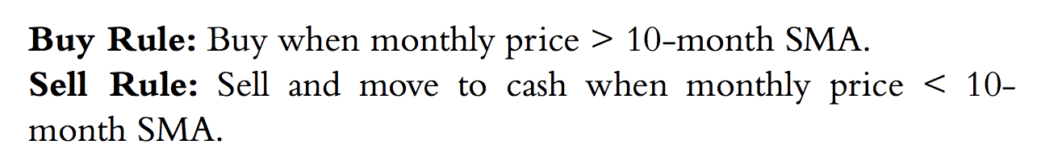

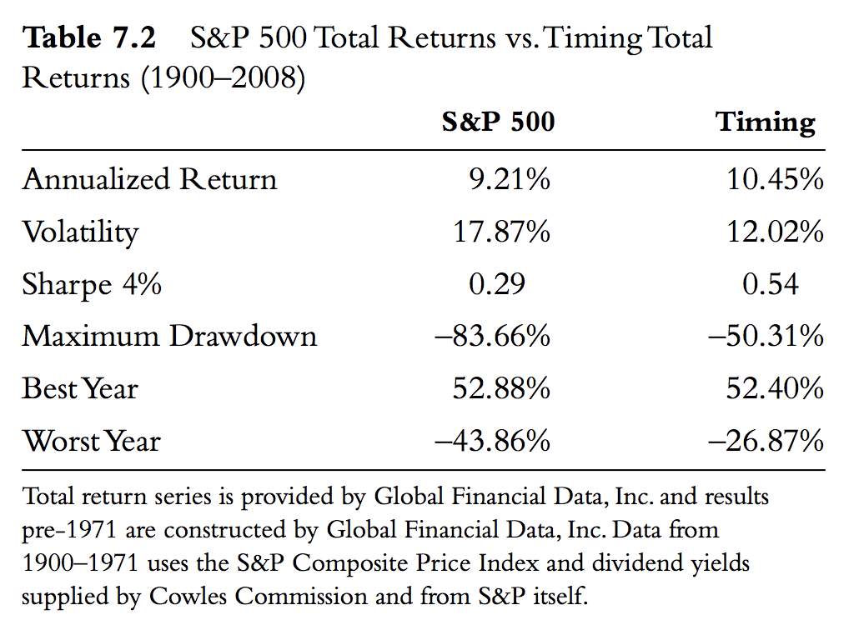

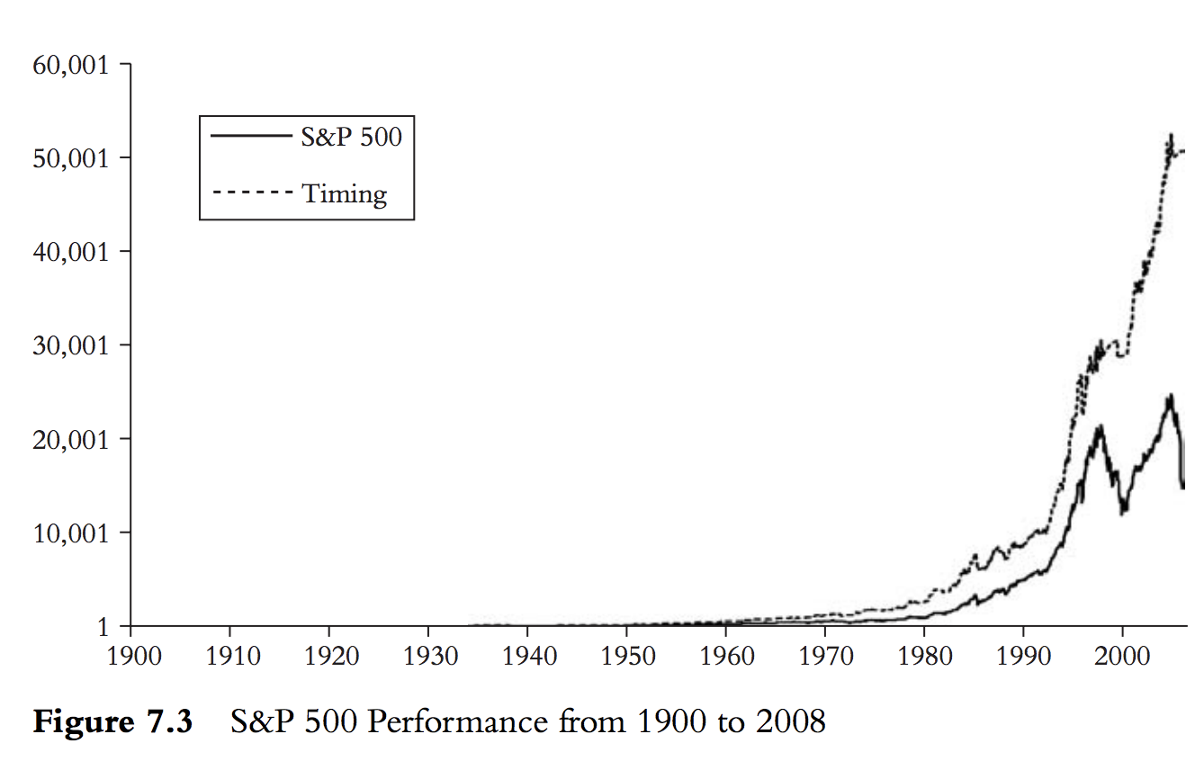

**Part 2: Other Resources**

Other papers that agree with the book

* <https://onlinelibrary.wiley.com/doi/abs/10.1111/irfi.12052>
* [The Trend is Our Friend: Risk Parity, Momentum and Trend Following in Global Asset Allocation](http://openaccess.city.ac.uk/17841/8/TREND%20IS%20YOUR%20FRIEND%20%20%20SSRN-id2126478.pdf)

Other papers that are skeptical

* [Revisiting the Profitability of Market Timing with Moving Averages](https://c.mql5.com/forextsd/forum/205/Revisiting%20the%20Profitability%20of%20Market%20Timing%20with%20Moving%20Averages__1.pdf)
* [Tactical asset allocation on technical trading rules and data snooping](https://www-sciencedirect-com.stanford.idm.oclc.org/science/article/pii/S0927538X18300775)

Other papers that are neutral

* <https://www.sciencedirect.com/science/article/abs/pii/S1062976917300443>
* <https://www.amazon.com/Market-Timing-Moving-Averages-Developments/dp/3319609696>
* [Limitations of Quantitative Claims About Trading Strategy Evaluation](https://papers.ssrn.com/sol3/papers.cfm?abstract_id=2810170)
* [538 on the replication crisis](https://fivethirtyeight.com/features/science-isnt-broken/#part1)